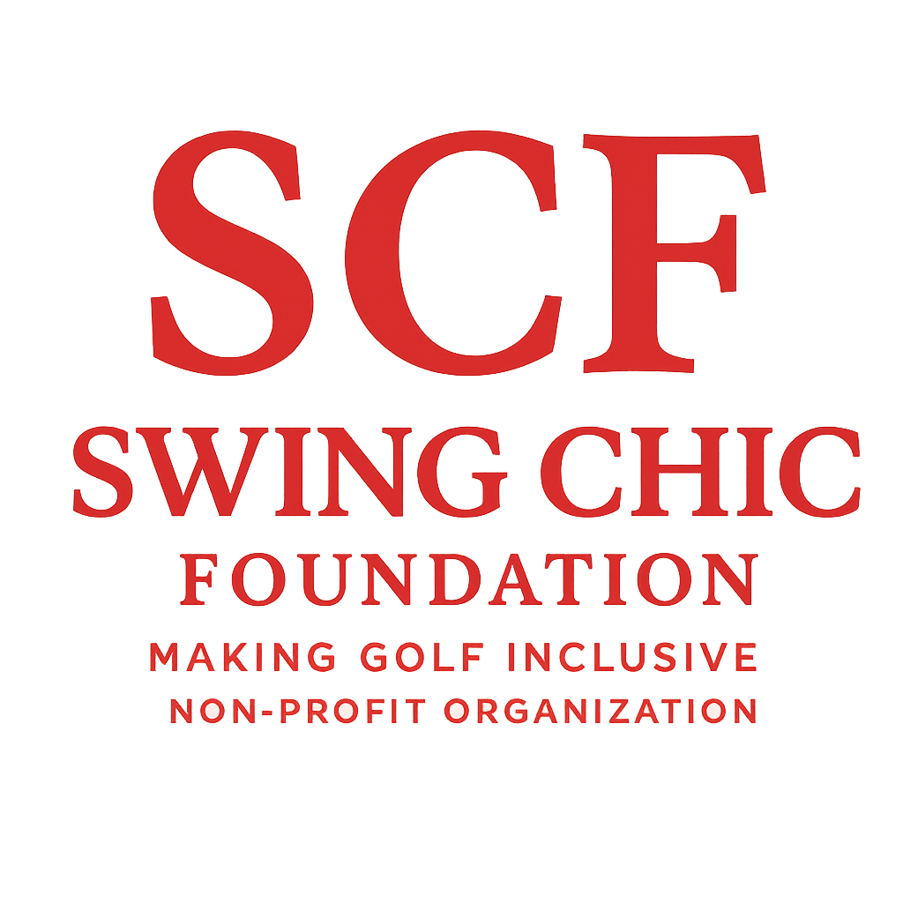

Swing Chic Foundation – Professional Golfer Sponsorship Levels

Level 1 – Apparel Sponsorship
Foundation Support Includes:
- Branded Swing Chic Foundation apparel package (golf polos, outerwear, hats, etc.)
Golfer Commitments:
- Wear Swing Chic Foundation apparel during tournament (when allowed) and public golf appearances.
- Tag and mention Swing Chic Foundation in a minimum of two (2) social media posts per month during the season.
- Provide at least one (1) photo and short testimonial video for promotional use on Swing Chic Foundation platforms.

Level 2 – Apparel & Tournament Entry Sponsorship
Foundation Support Includes:
- Full apparel package as described in Level 1
- Payment or reimbursement for approved tournament entry fees (upon 30-day request and verification)
Golfer Commitments:
- Fulfill all Level 1 commitments
- Participate in one (1) Swing Chic Foundation virtual or in-person interview (for social media or newsletter).
- Participate in at least one (1) community golf clinic, Girls Golf Coweta session, or similar outreach event representing the Foundation.

Level 3 – Full Sponsorship (Apparel, Entry Fees & Travel)
Foundation Support Includes:
- Complete apparel package
- Tournament entry fees (approved events only)
- Travel and lodging stipend for up to three (3) verified tournaments per season
Golfer Commitments:
- Fulfill all Level 1 & 2 commitments
- Participate in two (2) promotional photo or video shoots for Swing Chic Foundation marketing.
- Serve as a guest speaker at a Swing Chic Foundation event (such as Girls Golf Coweta, Special Needs Golf, or Dinner En Rouge).
- Represent Swing Chic Foundation in a professional and positive manner at all times on and off the course.

General Requirements
- All sponsorships are subject to a 30-day approval period and available funding.
- Golfers must provide a link or official verification of tournament participation.
- Continued sponsorship is contingent on maintaining active engagement, positive representation, and program alignment with Swing Chic Foundation’s mission to inspire and empower women and athletes through golf.

